Department of CSE(CYBERSECURITY)
Academic Year | 2025-26
Semester | I / II / III / IV / V / VI / VII / VIII
Event Title | CTFQuest
Event Type | FDP / Guest Lecture / Workshop / Seminar / Conference / Hackathon / Contest / Project Expo / Induction Program / Orientation Program / Celebration / Extension and Outreach / NSS / YRC / etc.,
Professional Society involved | IEEE / IETE / ISTE / IEI / IGEN / WiCys / Others
If the event is associated with CoE, mention the name of the CoE | Nil
Name of the resource person(s) with the organization and contact details: | NIL
Date & Duration | Start Date: | 4-02-2026 | Start Time: |  | 9.00 AM
 | End Date: | 4-02-2026 | End Time |  | 6.00 PM
Participants | No. of Student participants |  |  | 86
 | No. of Faculty participants |  |  | NIL
 | No. of External participants |  |  | Nil
Mode of Conduct (Online / Offline / Hybrid) | Offline
Venue | Algo Studio
Online Resource (Online / Hybrid) | Nil
Collaborators/ Industry Partners: | Infoziant
Whether it has been conducted through MoU? | Yes / No
If yes, please mention the name of MoU

Whether the event belongs to: IIC / Non – IIC
If the event is IIC, please fill the details below:
Thrust area
Activity / Event driven by
Quarter
Event Level
Event Theme

Report on the Event
Objectives:
1.To introduce the latest advancements in Capture The Flag (CTF) platforms and cybersecurity challenge design in the context of modern security practices.
2.To foster an understanding of the entrepreneurial strategies and innovations associated with building secure and scalable cybersecurity platforms.
3.To explore the practical applications and implications of CTF challenges such as OSINT, Web, and cloud security in various real-world scenarios.
4.To inspire participants to develop novel solutions and ideas in the field of cybersecurity and ethical hacking.
5.To encourage participants to engage in collaborative discussions and knowledge-sharing for the advancement of cybersecurity skills and practices.
Description of the event:
Round 1:
Session 1: Introduction to CTFQuest, overview of cybersecurity fundamentals, and briefing on platform architecture and competition guidelines.
Session 2: Hands-on setup of the CTF environment including deployment on local servers and cloud infrastructure.
Session 3: Training session on OSINT techniques, reconnaissance methods, and information gathering strategies.
Round2:
Session 1: Web security challenges covering common vulnerabilities such as injection flaws, authentication bypass, and misconfigurations.
Session 2: Cloud security and infrastructure session demonstrating deployment and management using Amazon Web Services EC2 instances and hybrid hosting.
Session 3: Live CTF competition with real-time challenge solving, monitoring, and scoring.
Round 3:
Session 1: Advanced challenges including privilege escalation, network analysis, and secure system design.
Session 2: Team collaboration, strategy discussions, and problem-solving workshops.
Session 3: Result announcement, feedback session, and knowledge-sharing with organizers and participants.
Outcomes:
1. Improved understanding of the applications and advantages of radial sealing dampeners in various industrial settings.
2. Enhanced entrepreneurial skills and innovative thinking among participants, leading to the development of novel solutions in the field of sealing technology.
3. Increased awareness of the latest advancements and trends in sealing technology, contributing to the overall knowledge base of the participants.
4. Strengthened connections and networks within the industry, fostering collaboration and potential partnerships for future ventures and projects.
5. Empowerment of participants to apply the knowledge gained from the program to real-world scenarios, leading to the implementation of effective sealing solutions in practical settings.
6. Potential for the generation of new ideas and approaches in sealing technology, fostering a culture of innovation and problem-solving within the field.

Benefit in terms of learning/Skill/Knowledge obtained:
1. Enhanced understanding of the principles and applications of radial sealing dampeners, leading to improved technical knowledge in the field.
2. Development of entrepreneurial skills by learning about the innovative solutions and strategies related to sealing technology.
3. Acquiring practical knowledge about the implementation and operation of sealing technology in various industrial contexts.
4. Exposure to the latest advancements in sealing technology, fostering a broader perspective on the industry and its potential for innovation.
5. Opportunity to engage in discussions and networking with industry experts, enabling participants to gain insights and perspectives from experienced professionals.

Outcomes:
1.Improved understanding of the applications and advantages of Capture The Flag platforms in developing real-world cybersecurity skills.
2.Enhanced technical and analytical skills among participants, leading to the development of effective solutions for security challenges.
3.Increased awareness of the latest advancements and trends in cybersecurity and cloud infrastructure, contributing to the overall knowledge base of the participants.
4.Strengthened connections and networks within the cybersecurity community, fostering collaboration and potential partnerships for future projects.
5.Empowerment of participants to apply the knowledge gained from the program to real-world scenarios, leading to the implementation of secure systems and best practices.
6.Potential for the generation of new ideas and approaches in cybersecurity, fostering a culture of innovation and problem-solving within the field.Improved understanding of the applications and advantages of Capture The Flag platforms in developing real-world cybersecurity skills.
7.Enhanced technical and analytical skills among participants, leading to the development of effective solutions for security challenges.
8.Increased awareness of the latest advancements and trends in cybersecurity and cloud infrastructure, contributing to the overall knowledge base of the participants.
9.Strengthened connections and networks within the cybersecurity community, fostering collaboration and potential partnerships for future projects.
10.Empowerment of participants to apply the knowledge gained from the program to real-world scenarios, leading to the implementation of secure systems and best practices.
Potential for the generation of new ideas and approaches in cybersecurity, fostering a culture of innovation and problem-solving within the field.

NAME OF THE SDG GOALS MAPPED
MENTION THE SDG GOALS NUMBER

POs & PSOs Mapping (Put a tick mark in the mapped PO’s & PSO’s):
Program Outcomes |  |  |  |  |  |  |  |  |  |  | Program Specific Outcomes
PO1 | PO2 | PO3 | PO4 | PO5 | PO6 | PO7 | PO8 | PO9 | PO10 | PO11 | PSO1 | PSO2

Funding Details:
Funding Provided by | Institute / External / No Funding
Expenditure amount (in Rs.) | NIl
Social media Coverage (Provide links):
YouTube
Facebook
Instagram
LinkedIn

Sample Photograph 1:
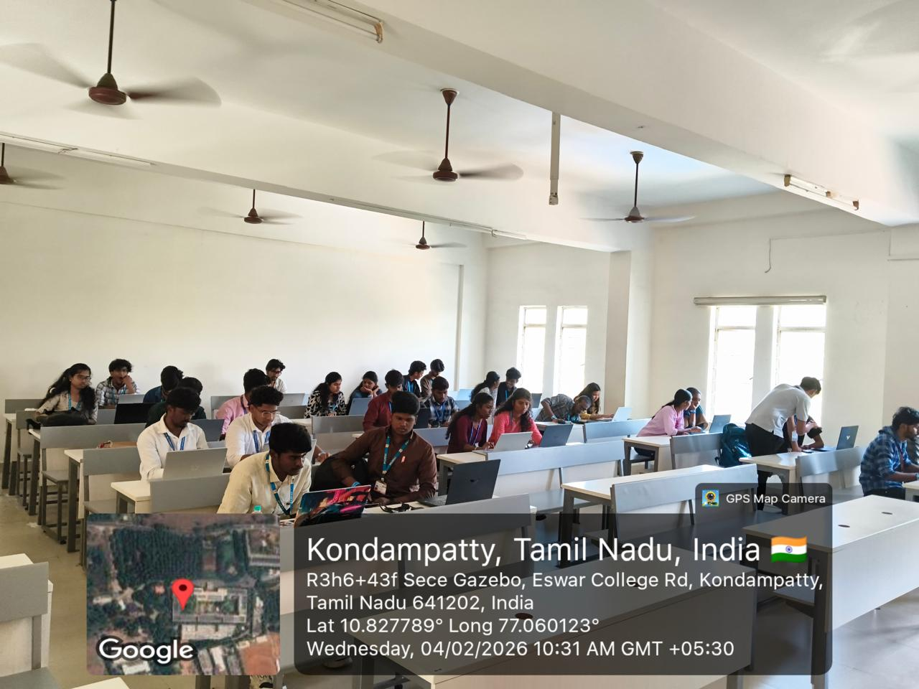

Sample Photograph 2: 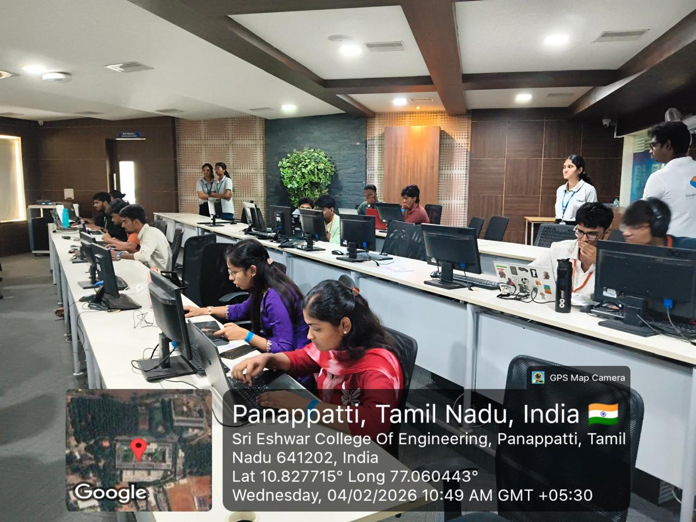

Enclosures: 1. Approval Letter, 2. Brochure, 3. Schedule, 4. Attendance Sheet, 5. Feedback forms 6. Geo Tagged Photographs, 7, Account Settlement details, 8. etc.,
Prepared by  Faculty Coordinator | Verified by  Head of the Department

